Geoffrey Lebbos

CSS 490 B

Spring 2017

Assignment 2 Report

**About**

This program is built on top of the C# sample code provided on Canvas.

**Running the program**

After extracting the zip folder, navigate to Project1.exe by clicking on Project1🡪bin🡪Debug🡪Project1.exe

Double click Project1.exe and a screen will appear with 4 different buttons. Click on “Load Query Picture” and choose an image to load.

After choosing an image, click on either “Search By Intensity”, “Search By Color”, or “Search by Intensity and Color”. Clicking on any of these buttons will cause the system to load for about 30 seconds while it processes all the images in the image file directory.

After about 30 seconds, a page will be displayed with the results of your search. The big picture displayed towards the right of the window is the query picture you loaded. The smaller pictures are the results, ranging from most relevant to least relevant (left-right, top-down).

Clicking on “Next Page” at the bottom right of the window will cause a new page of pictures to display. Clicking on “Previous Page”, also at the bottom right of the window, will take you back to the page prior.

Clicking on any of the smaller pictures (the results) will cause them to become the query image.

Clicking on any 3 of the search buttons will produce results based on the current query image. Clicking on the “Select Relevance” checkbox will allow you to select images as “relevant” by clicking the corresponding checkbox underneath those images. The “Search by Color and Intensity” method is the only search option affected by relevant images. After selecting relevant images, you may “search by intensity and color” to produce new results.

Image 1 query using intensity + color code + RF

Initial result (before doing RF, with relevant image selected which will be used for RF analysis):

(Next page)

**Precision value:** 9/20

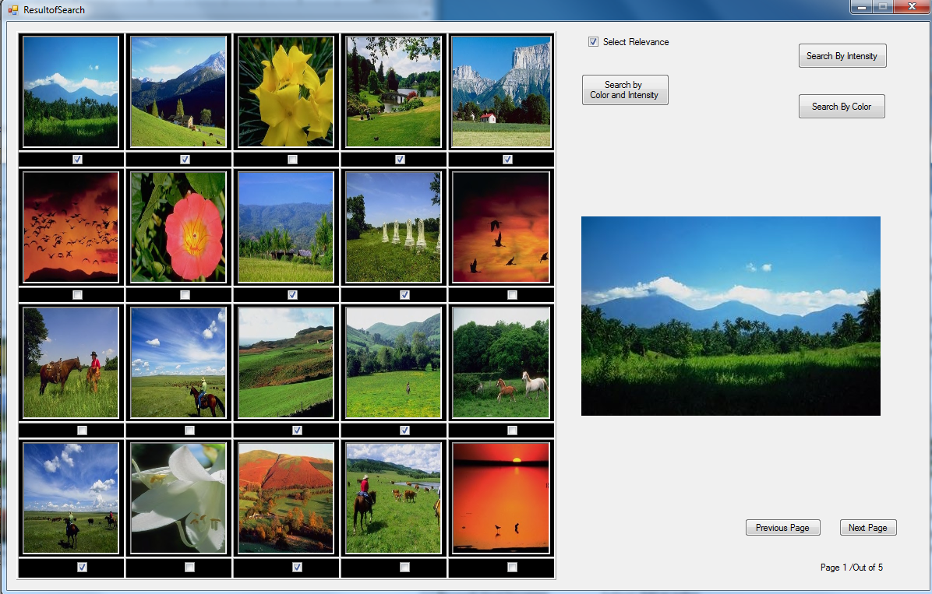

1st iteration result: **Precision value:** 13/20

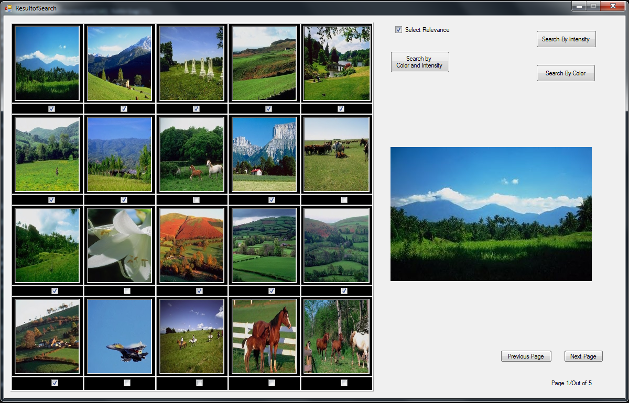

2nd iteration result: **Precision value:** 14/20

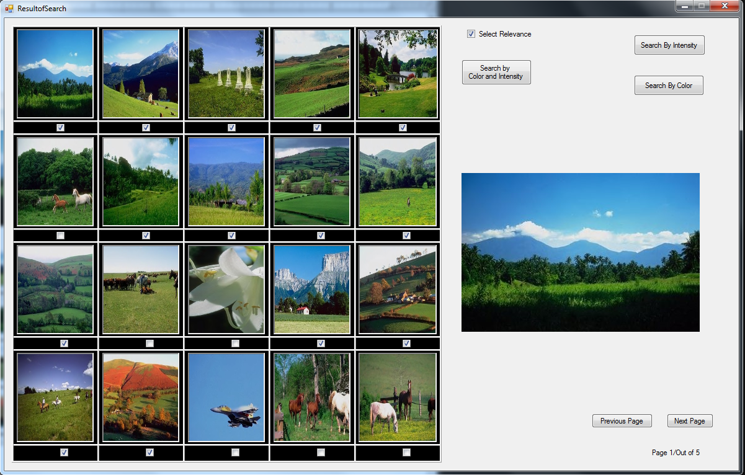

3rd iteration: **Precision value:** 14/20

(Next page)

